**Today(13/09/2020):**

IDM Execution commands:

Conditional Statements:

**Vi If.sh:**

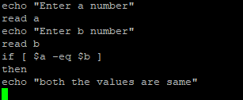

**Output:**

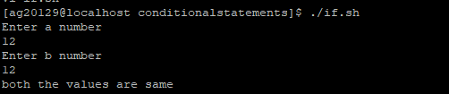

Ifelse:

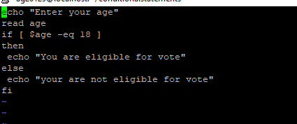

Output:

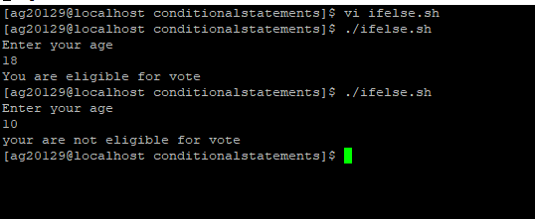

Ifelseif:

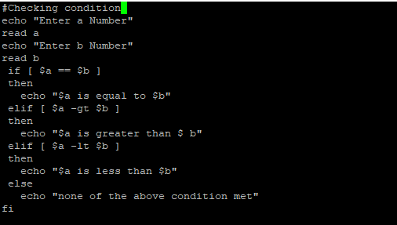

Output:

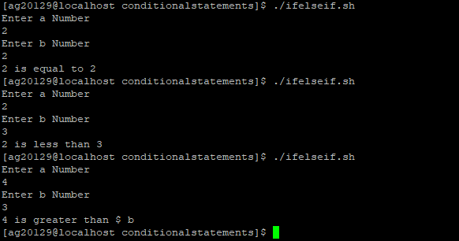

Looping statements in Unix:

1. for loop
2. While loop
3. Until loop

**1.For loop:**

1. For Numbers :

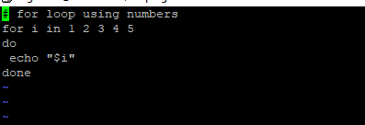

Output:

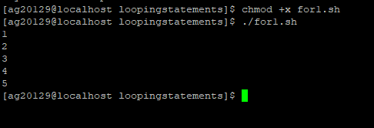

**1_1 way for loop:**

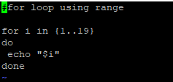

#for loop using range

for i in {1..19}

do

echo "$i"

done

~

Output:

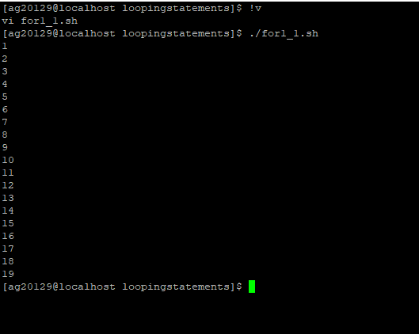

1. For loop for strings:(for2.sh)

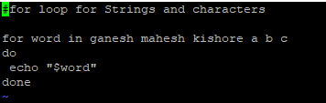

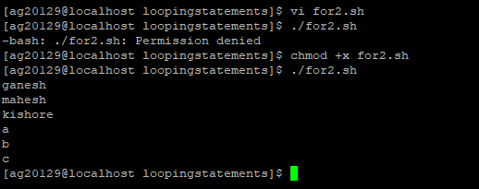\

1. Normal Type:

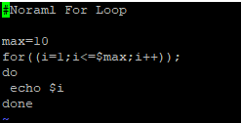

Code:

#Noraml For Loop

max=10

for((i=1;i<=$max;i++));

do

echo $i

done

**Output:**

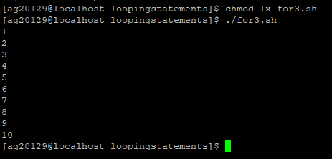

**While loop:**

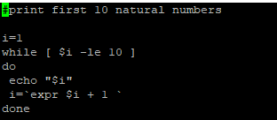

Code:

#print first 10 natural numbers

i=1

while [ $i -le 10 ]

do

echo "$i"

i=`expr $i + 1 `

done

**Output:**

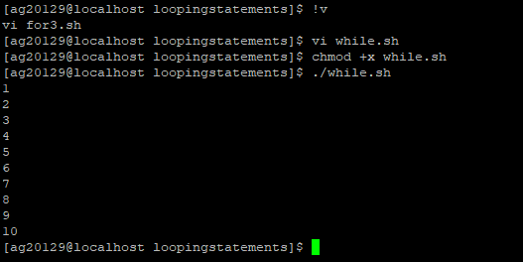

**Until Loop:**

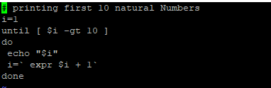

**Code:**

# printing first 10 natural Numbers

i=1

until [ $i -gt 10 ]

do

echo "$i"

i=` expr $i + 1`

done

**Output:**

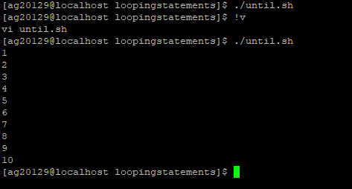

Switch:

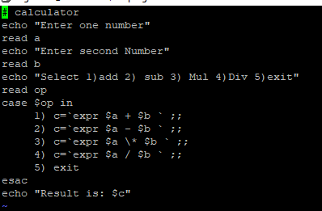

Code:

# calculator

echo "Enter one number"

read a

echo "Enter second Number"

read b

echo "Select 1)add 2) sub 3) Mul 4)Div 5)exit"

read op

case $op in

1) c=`expr $a + $b ` ;;

2) c=`expr $a - $b ` ;;

3) c=`expr $a \* $b ` ;;

4) c=`expr $a / $b ` ;;

5) exit

esac

echo "Result is: $c"

**Output:**

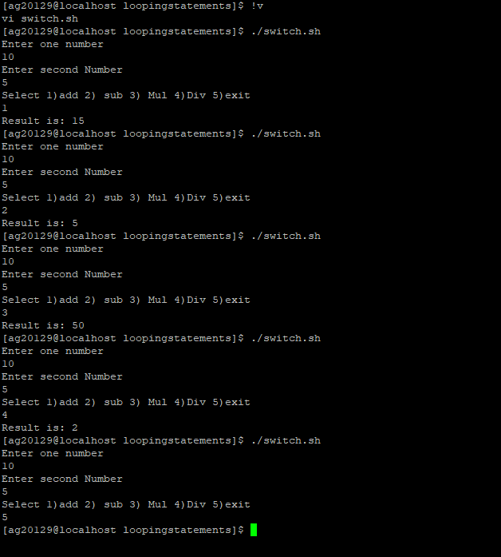

Task:

Arith.sh:

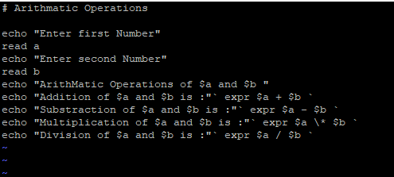

**Code:**

# Arithmatic Operations

echo "Enter first Number"

read a

echo "Enter second Number"

read b

echo "ArithMatic Operations of $a and $b "

echo "Addition of $a and $b is :"` expr $a + $b `

echo "Substraction of $a and $b is :"` expr $a - $b `

echo "Multiplication of $a and $b is :"` expr $a \* $b `

echo "Division of $a and $b is :"` expr $a / $b `

**Output:**

